**Coplin’s Book (summary)**

* Professor Bill Coplin
* Author of *10 Things Employers Want you to Learn in College*
* Director Public Affairs Program, Maxwell School and College of Arts and Sciences, Syracuse University

<http://info.brooklyn.cuny.edu/confluence/download/> attachments/2589589/10+Ten+Employers+Want+You+To+Learn.pdf

**Goal of Presentation**

* Plan Your College Years So You are Ready for the Job Market When You Graduate Starting **NOW**

# Good News About Undergraduate Education

***Lifetime Earnings:***

* $1.2m for HS grad
* $2.1m for College Grad
* $4.4m for professional degree

# Bad News About Undergraduate Education

* 63% of students who begin at a four-year college do not finish in 4 years and 42% do not finish in 6 years.
* 67% of graduating seniors in 2007 borrowed a mean average of $22,700.
* 60% of college graduates plan to live with their parents after graduation.
* 20% of 450 employers say that students are not prepared for the work force.

# GPA is not as important as your Know- how Score (KHS)

* + **452 Employers Rank GPA as 17 on a list of 20 skills they are looking for.**

**What’s the X?**

* + A College Degree and a Dollar Will Get You Four Quarters
  + A College Degree + X = Satisfying Career

**Employers rate the importance of candidate qualities/skills**

|  |  |
| --- | --- |
| 1. Communication skills  (verbal and written) | 11. Detail oriented |
| 2. Honesty/integrity | 12. Leadership skills |
| 3. Teamwork skills (works well with others) | 13. Self-confidence |
| 4. Interpersonal skills (relates well to others) | 14. Friendly/outgoing personality |
| 5. Strong work ethic | 15. Well mannered/polite |
| 6. Motivation/initiative | 16. Tactfulness |
| 7. Flexibility/adaptability | **17. GPA (3.0 or better)** |
| 8. Analytical skills | 18. Creativity |
| 9. Computer Skills | 19. Sense of humor |
| 10. Organizational Skills | 20. Entrepreneurial skills/risk-taker |

**Establishing a Work Ethic**

* + Kick Yourself in the Butt



* + Be Honest
  + Manage Your Time

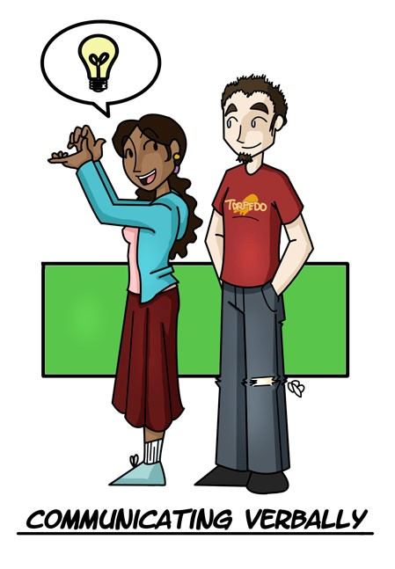

# Communicating Well

**Communicating Well**

* + Converse One-on-One
  + Present to Groups
  + Use Visual Displays

***COMMUNICATING THROUGH PRESENTATIONS***

# Communicating Well (continued)

**Communicating Well (continued)**

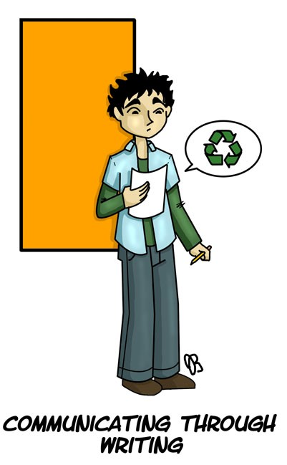

* + Write Well
  + Edit and Proof
  + Use Word-Processing Tools
  + Send Information Electronically

***COMMUNICATING THROUGH***

***Writing***

**Working Directly with People**

* + Build Good Relationships
  + Work in Teams
  + Teach Others



**Gathering Information**

* + 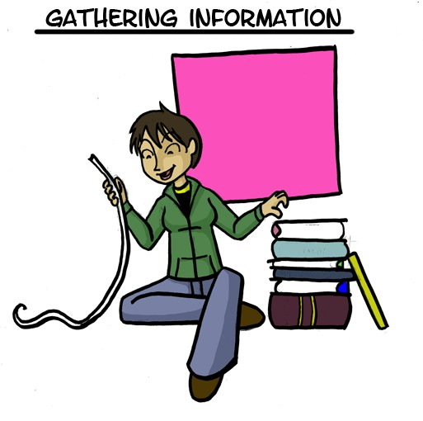Use Google Scholar
  + Use the Library Databases
  + Search the Web
  + Construct Surveys



**Using Quantitative Tools**

* + Use Numbers
  + Use Graphs and Tables
  + Use Spreadsheet Programs



**Asking & Answering the Right Questions**

* + Detect Nonsense
  + Pay Attention to Detail
  + Apply Knowledge

