# A Brief Guide to Scientific Replication, via @Nbcthegoodplace

**Jess Hartnett** @**Notawful** https://twitter.com/Notawful/status/1086409585949376512



**📊**

“Holy shirtballs. we can [use] … @**nbcthegoodplace** to teach” about replication! [Season 3, Episode 11]

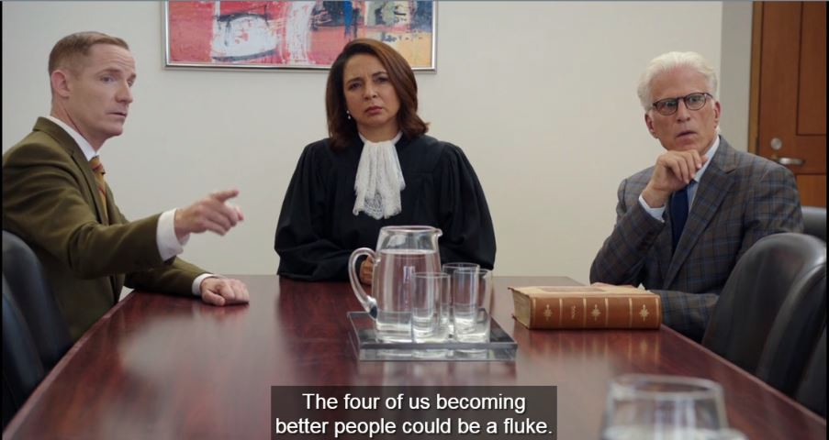

[Caption: The four of us becoming better people could be a fluke.]

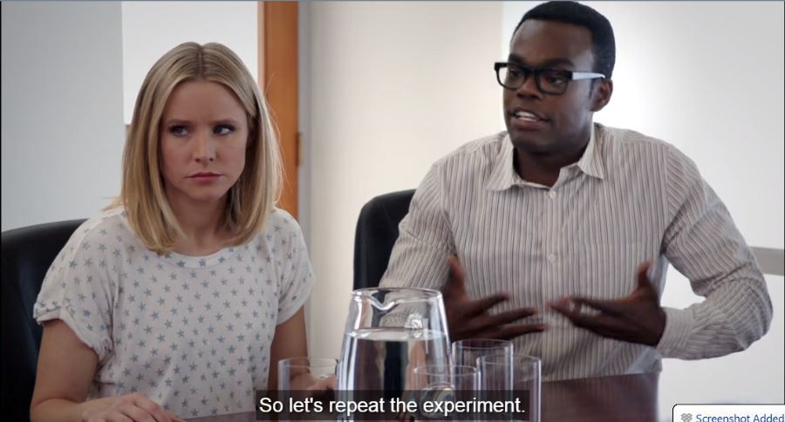

[Caption: So let’s repeat the experiment.]

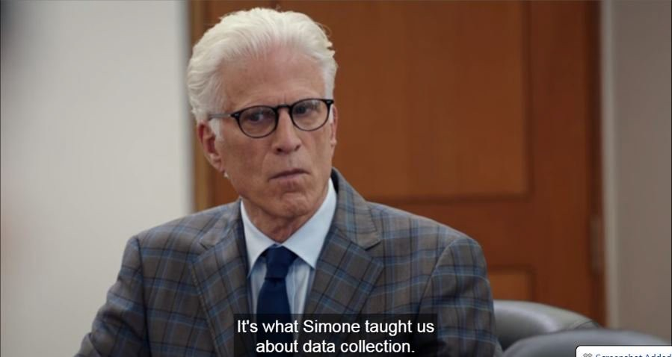

[Caption: It’s what Simone taught us about data collection.]

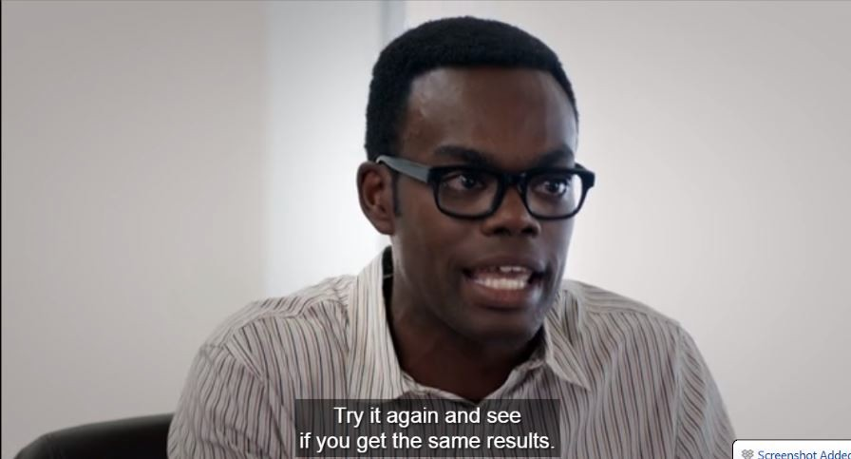

# [Caption: Try it again and see if you get the same results.]

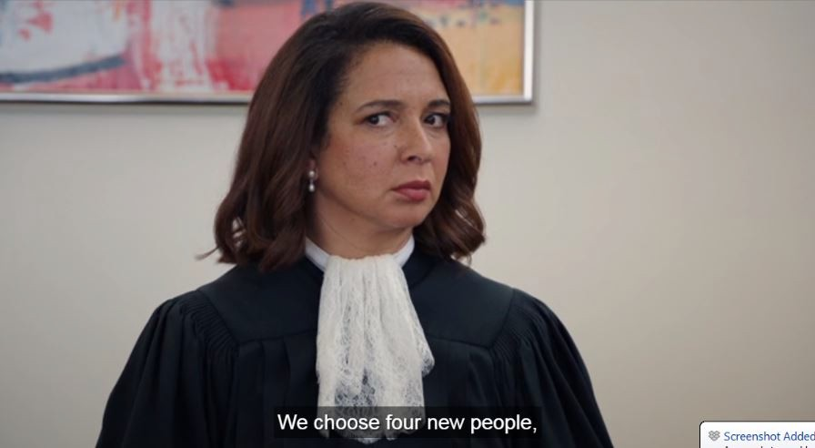

[Caption: We choose four new people,]

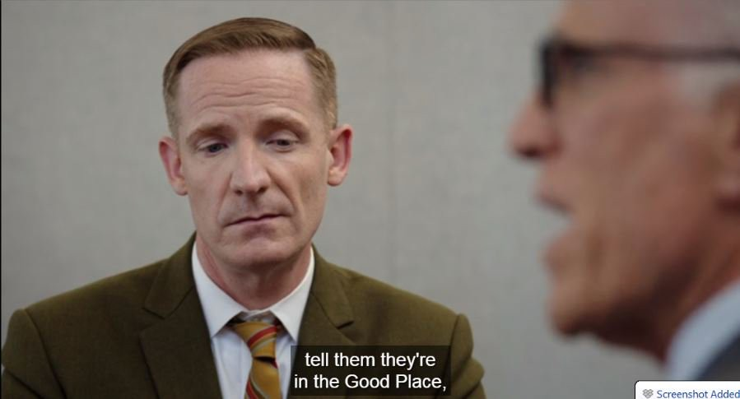

[Caption: tell them they’re in the Good Place,]

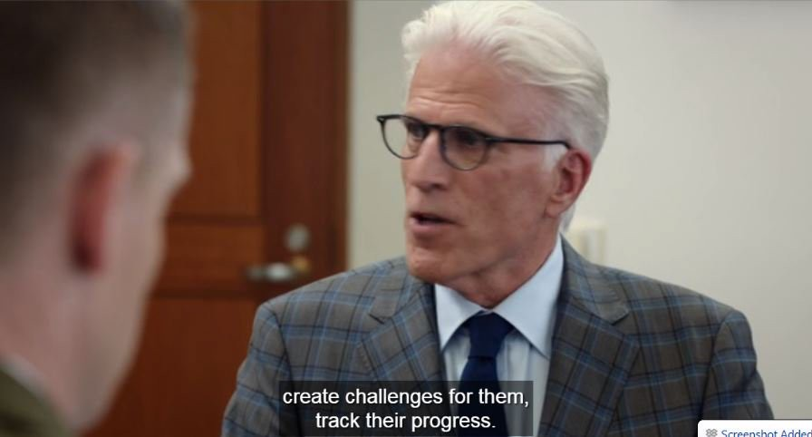

[Caption: create challenges for them, track their progress.]