https://twitter.com/RottenInDenmark/status/1106604049187495937

**Michael Hobbes**



@RottenInDenmark

Reminder that nearly all diet studies linking a single food to a single health outcome are essentially worthless.

Researchers get a huge dataset, then p- hack their way through it looking for correlations. The eﬀect sizes are tiny, noisy, and often non-replicable.

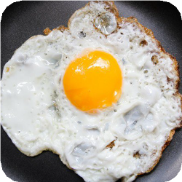

**CNN**  @CNN

Three or more eggs a day increase your risk of heart disease and early death, study says cnn.it/2TQxRzt

12:12 PM - 15 Mar 2019





**4,841** Retweets **12,627** Likes

 **144**  **4.8K 13K** 