https://support.office.com/en-us/article/save-a-presentation-as-a-movie-file-or-mp4-4e1ebcc1-f46b-47b6-922a-bac76c4a5691

**Save a presentation as a movie file or MP4**

# **Save in a video format**

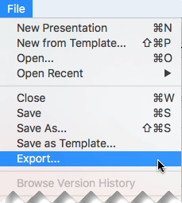!. Select **File** > **Export**.

(Don't use **Save As**, because it doesn't offer video options.)

;. Open the **File Format** list and select the video format that you want (**MP4** or **MOV**).

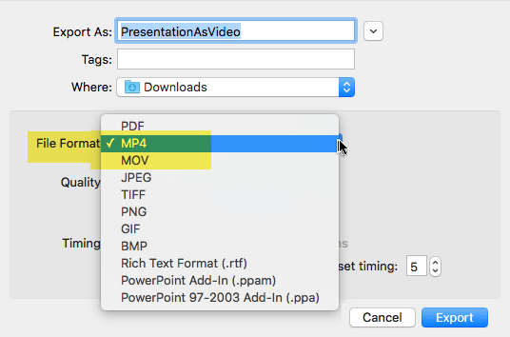

If the MP4 and MOV options aren't in your version of PowerPoint, see Requirements below for more information.

H. Select the video **Quality** you want: **Presentation Quality**, **Internet Quality**, or **Low Quality**. The higher the video quality, the larger the file

size.

Professor Gernsbacher recommends you use "Internet Quality."

M. If you have recorded timings and want to use them in the video you create from your presentation, make sure the box next to **Use Recorded Timings and Narrations** is checked. You can also choose to set the amount of time the video will spend on each slide if you don't have a set timing.

Q. When you've made all your selections, choose **Export**.

**Note:** When you export your presentation as a video, any narrated audio that was recorded in Slide Show will play, but other embedded media files won't play.

After you've saved your presentation as a video, you can share it just as you

would any other video, by using applications or devices that can open and play videos.

# **Requirements for saving in a video format**

|  |  |
| --- | --- |
| a bunch of check marks next to a list. | **Applies to:**  PowerPoint for Office 365 for Mac  **Version** 15.23 and later. Beginning in version 16.19, recorded narration is included in exported video files.  **License**: Office 365 Subscription  Find your Office version NOTE: If you only have access to PowerPoint 2016 |
|  | **Applies to:** for Mac OR if your version of PowerPoint for Office  365 for Mac is earlier than version 16.19, you will not  PowerPoint 2019 for Mac be able to record a narrated video with PowerPoint.  **Version** 16.19 and later. Be sure to read the information on the Course  Find your Office version Website for what to do instead! |