# How to Create a Narrated Prezi Presentation PSY 225 (prepared by Nathaniel Rigier)

**NOTE:** You’ll need to create sound files via a third-­‐party recorder. Programs to do this should already be installed on your computer: For Windows, it’s **Sound recorder** (known as **voice recorder** in Windows 10), for Mac (Apple), it’s **QuickTime**. Each Prezi slide will need a separate sound file.

# Recording Narration with Windows

Click on the **Start** menu and search for **Sound Recorder** (sometimes called Voice Recorder). Using Sound Recorder, press **Start Recording.** When you’ve finished recording, press **Stop Recording**, which will automatically bring up a Save window that will ask you to name the file and choose where you want to save the file. Repeat this sequence to create a narration for each Prezi slide.

# Recording Narration with Macs (Apple)

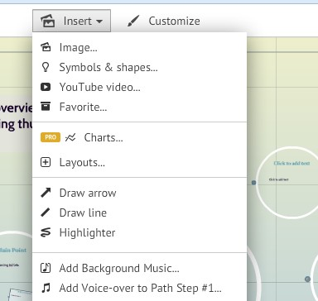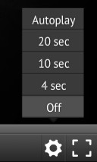

Open **QuickTime**, select new **Audio Recording** and record your narration. Press **Stop Recording** when you’ve completed the narration for one slide. Repeat this sequence to create a narration for each Prezi slide.

# Adding your Recording to Prezi

Open your completed Prezi and click **Insert on your initial slide,** which will open a dropdown box. Click **Add Voiceover to Path Step**, which will open a dialogue box where you can select (from your computer) your previously recorded file. Select the file you want to upload and click **Open**; the upload will automatically begin. Repeat this step for each of your slides.

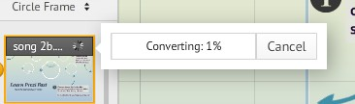

You can set up an automatic timer to move slides forward while others watch by clicking **Present** in the upper-­‐right corner. Once the presentation opens in full screen, click on the **Gear** icon in the lower-­‐right corner and select **Autoplay**. Select the amount of time you want from each slide (4 sec, 10 sec or 25 sec) and make sure that your narrations are not longer than your automatic timings!

# Uploading your Prezi to Canvas

There are two ways to share your Prezi: either by sharing the link or by embedding the code to Canvas. First make sure your Prezi is set to **Public**. (You can check

this under **Account Settings**). If you want to share your code via a link, first click **Share** below the completed Prezi. Copy the link that is generated in the **Copy Link** text box.

On the Discussion Board, in the typical place where you type, embed a link using the link (the URL) you copied from Prezi (via Copy Link).

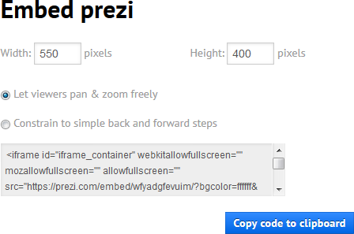

If instead you want to **embed** your Prezi, click the **Embed** button below your completed Prezi. Make sure your width is set to **550** pixels and click **Copy Code to Clipboard.** On the Discussion Board, in the typical place where you type, click on **HTML editor** (in the upper right-­‐hand corner) and paste in the embed code. Click **Post Reply** to post your embedded Prezi!



1. In the text box click

# HTML editor