# How to Upload Your Narrated Presentation Video File to the Discussion Board PSY 225 (prepared by Nathaniel Rigier)

1. On the Discussion Board, click on the **Record/Upload Media** icon, which is to the right of the blue downward ‘v’ that you use to embed YouTube or Vimeo videos.

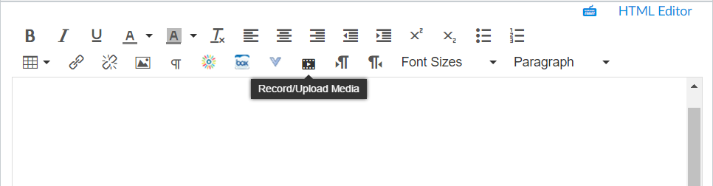

1. Select the **Upload Media** tab and then click **Select Video File**, which will open a window from which you can find your video file on your computer. Select the video file you want to upload from your computer and click **Open.**

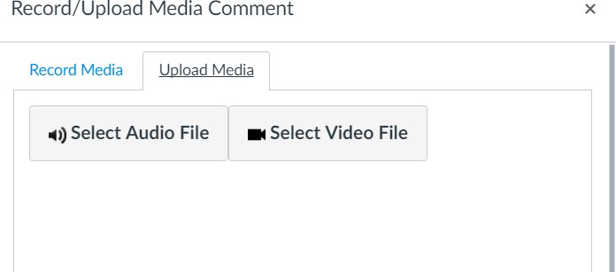

1. Note that uploading video files, particularly large files, can take time. Make sure that you are on high-­‐speed Internet and that you have a lot of bandwidth available (no one else on your network is playing video games or also trying to upload a large file).
2. After your video has uploaded, you can test it before you post your Discussion Board post. If you’re not happy with the video, then delete it, and re-­‐upload it.

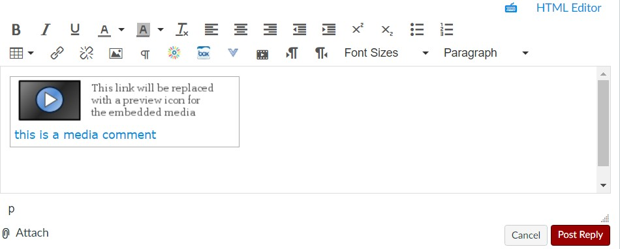

# Be sure to click “Post Reply” (as you always do) after you have finished uploading your video.