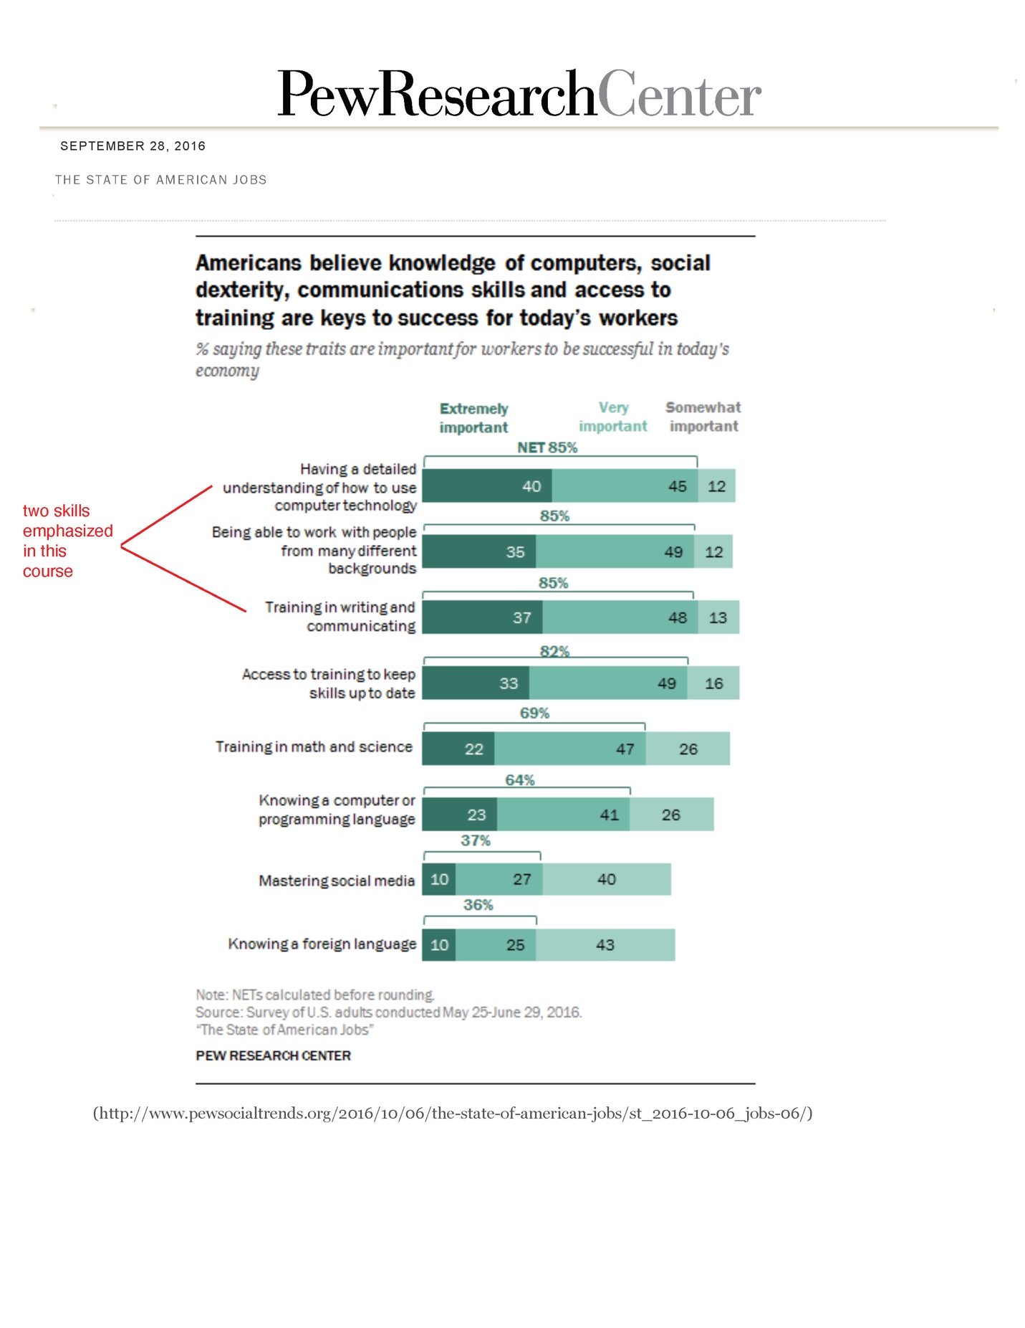

# The State of American Jobs - Text-Only Version

Pew Research Center

September 28, 2016

## Americans believe knowledge of computers, social dexterity, communications skills and access to training are keys to success for today’s workers

## Percentage saying these traits are important for workers to be successful in today’s economy:

### Having a detailed understanding of how to use computer technology

Extremely or Very Important: 85%

### Being able to work with people from many different backgrounds

Extremely or Very Important: 85%

(Note: the above two skills are emphasized in this course)

### Training and writing in communication

Extremely or Very Important: 85%

### Access to training to keep skills up to date

Extremely or Very Important: 82%

### Training in math and science

Extremely or Very Important: 69%

### Knowing a computer or programming language

Extremely or Very Important: 64%

### Mastering social media

Extremely or Very Important: 37%

### Knowing a foreign language

Extremely or Very Important: 36%

Source: survey of U.S. adults conducted May 25 – June 29, 2016

“The State of American Jobs”

Pew Research Center

For full report please visit <https://www.pewsocialtrends.org/2016/10/06/the-state-of-american-jobs/st_2016-10-06_jobs-06/>