[CAREERS](http://www.cnbc.com/make-it/careers/)

Google exec, Mark Cuban agree that these college [skills] are the most robot-resistant

[Marguerite Ward](http://www.cnbc.com/marguerite-ward/) | [@forwardist](http://twitter.com/forwardist) | Friday, 21 Apr 2017 | 4:08 PM ET

CNBC Logo

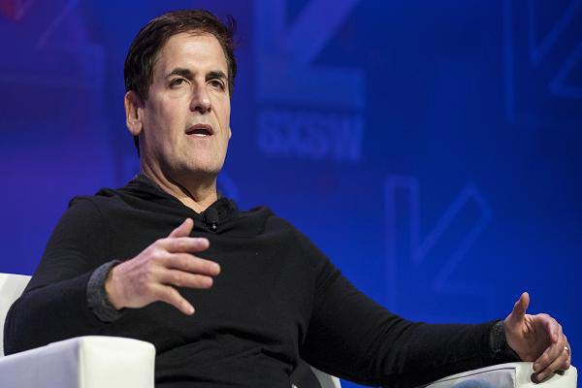

[1 Monday, 13 Mar 2017 | 9:31 AM ET | 00:46](http://video.cnbc.com/gallery/?video=3000600718)

If self-made billionaire Mark Cuban was starting college right now, he'd choose philosophy as his major over accounting.

That's because [he strongly believes](http://www.cnbc.com/2017/02/20/mark-cuban-robots-unemployment-and-we-need-to-prepare-for-it.html) artificial intelligence will automate many jobs involving technical tasks, such as an accountant's. Jobs that rely more on personal judgement, critical thinking and creativity — skills more often associated with a liberal arts degree — are less at risk, he says.

"Knowing how to critically think and assess them from a global perspective I think is going to be more valuable," [Cuban](http://www.cnbc.com/2017/03/13/mark-cuban-the-worlds-first-trillionaire-will-be-an-ai-entrepreneur.html) said, speaking at [SXSW](https://www.sxsw.com/) in March, "than what we see as exciting careers today which might be programming or CPA or

those types of things."

Jobs that require strong cognitive abilities and analytical thinking will be very difficult to replace with AI, according to the Google exec, who previously was the SVP of product for the company.

*"We need more traditional liberal arts grads."*

-Jonathan Rosenberg, adviser to Alphabet CEO Larry Page

Technology will impact some 60 percent of all occupations, according to a July 2016 [report by McKinsey](http://www.mckinsey.com/business-functions/digital-mckinsey/our-insights/where-machines-could-replace-humans-and-where-they-cant-yet). For professionals in these jobs, the report says, 30 percent or more of their activities will be automated over the next several years.

Jobs that require high levels of creativity or people management are the least at risk, the report says.

Cuban and Rosenberg aren't the only tech leaders talking about AI's impact on the job market.

Theoretical physicist Stephen Hawking, SpaceX and Tesla CEO Elon Musk and dozens of other leaders penned [an open letter](http://www.cnbc.com/2015/07/27/hawking-musk-warn-of-inevitable-ai-arms-race.html) in 2015 about the potential dangers AI poses to jobs and humanity. Musk says that so many jobs will be replaced by AI it may lead to the creation of a [universal basic income](http://www.cnbc.com/2016/11/04/elon-musk-robots-will-take-your-jobs-government-will-have-to-pay-your-wage.html), with governments providing citizen's with a wage.

According to Rosenberg and Cuban, a liberal arts degree may still be your best insurance against the coming robot workforce.