**How To Do Various Things in PSY 311 (Dr. Suss)**

(To Read More about each Topic below, Click on the Title of the Topic)

Basics 2

How to Control the Size of the Display on Your Screen 2

How to Open a Link in a New Browser Window or Tab 2

How to Access the Course Website 2

Discussion Boards 3

How To Make a New Discussion Board Post 3

How To Make a Reply to a Discussion Board Post 5

How do I Respond to Other Students’ Discussion Posts? 6

How To Edit a Discussion Board Post 7

How To Embed a YouTube Video or Vimeo Video into a Discussion Board Post 8

How To Embed a URL into a Discussion Board Post 10

How To Embed an Image into a Discussion Board Post 12

How to Attach a PDF to a Discussion Board Post 13

My Grades 14

How To Check the Points You’ve Earned in this Course 14

How To Correct an Assignment and Notify the Instructor to Re-Score It 15

Chats 16

How to Find Out Which Chat Group You Are In 16

How to Contact Other Members of Your Chat Group 17

How to Set Up a Group Text Chat using Chatzy.com 18

How to Participate in a Group Text Chat 19

What to do if… 20

How to Save and Attach a Group Text Chat Transcript 21

# Basics

## How to Control the Size of the Display on Your Screen

When viewing any webpage on the Internet, you might want to increase the size of the display so it fills more of your screen (or, conversely, decrease the size of the display so it doesn’t hang off your screen). On a Mac/Apple, press the ‘Command’ key and the + key simultaneously to increase or ‘Command’ Key and minus key to decrease the size of your display. On Windows, press the ‘Control’ key simultaneously with the + key to increase or ‘Control’ key and minus key to decrease the size of your display.

## How to Open a Link in a New Browser Window or Tab

If you’re using a mouse with buttons, then right click (i.e., depress the button on the right) or if you’re not using a mouse or if your mouse doesn’t have buttons, press ‘Control’ at the same time as you click on a link, and you’ll be given the options to “Open in a New Window” or “Open in a New Tab.”

## How to Access the Course Website

All content for this course is on the Course Website: <https://psy311.wichita.edu>. **Be sure to bookmark that URL**. Although this course also uses Blackboard for the Discussion Boards, Assignments, and My Grades, do NOT try to access the Course Website through MyWSU (or through Blackboard). Rather, ALWAYS GO TO THE COURSE WEBSITE (<https://psy311.wichita.edu>).

# Discussion Boards

## How To Make a New Discussion Board Post

In this course, you’ll be using the Discussion Board quite a bit. The Discussion Boards are hosted on the Blackboard course web site. There are is a separate Discussion Board for each assignment.

Each time you are assigned to post on the Discussion Board, you should log onto Blackboard and then click “Units” (1) and then select the unit you are working on (2).

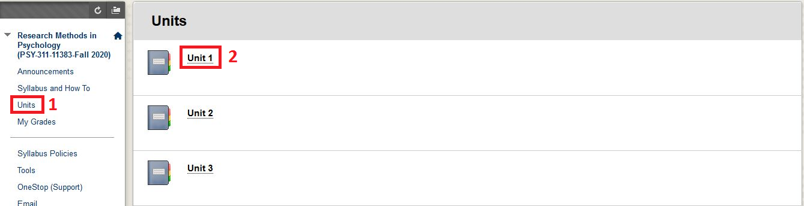

Once you are in the unit, you will see a list of Discussion Board. For example, the Assignment might say, “Go to the **Unit 1: Assignment #2 and #4 Discussion Board**.” Click the name (1) and then “Click to launch” (2).

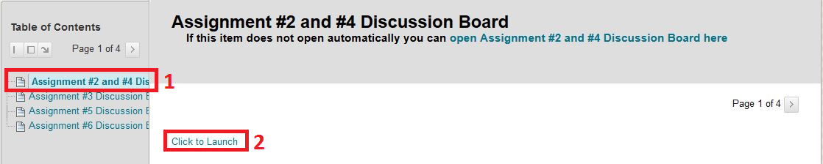

When the Discussion Board opens, you should see something like this. All of the Discussion Boards are “post-first.” This means that you cannot rea other students’ posts until you have posted your own thread. Click on “Create Thread.”

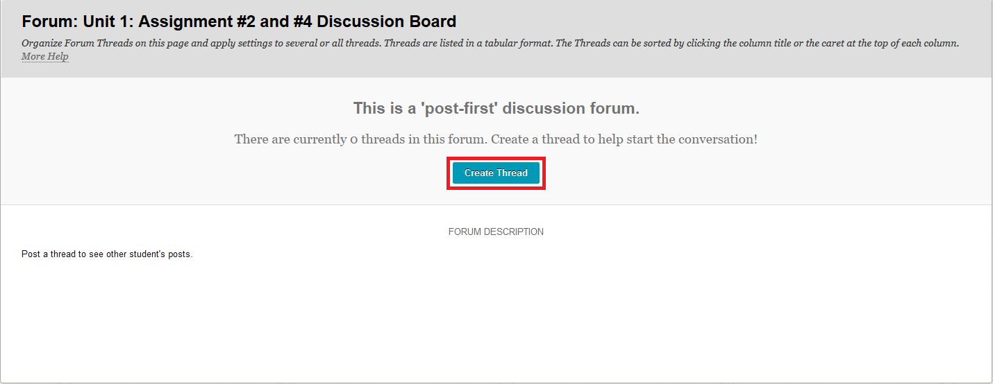

You should now see a “Create Thread” box like the one below. In the “Subject” box, type in the name of the Assignment (e.g., Unit 1: Assignment #2). Then there is a “Message” box with menu icons. We’ll talk more about how to use those menus/icons later, but to create a new thread, simply begin to type into the “Message” box (see red arrow).

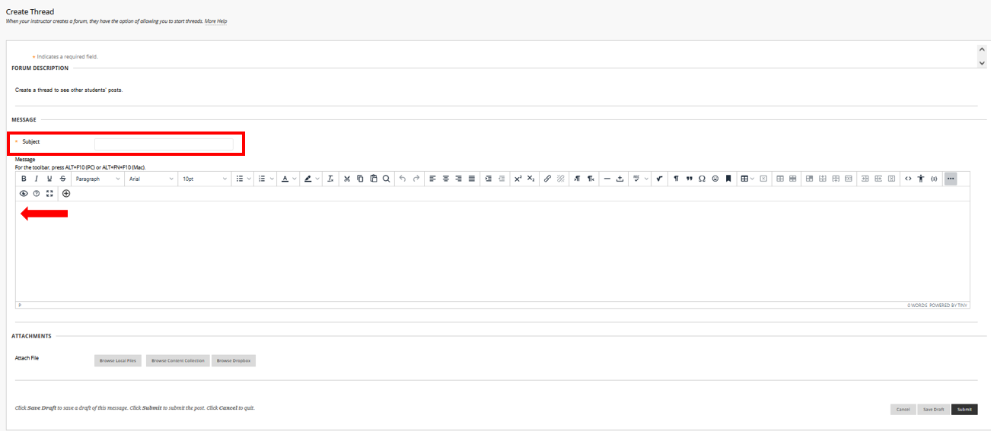

You can also compose your post elsewhere (e.g., in Microsoft Word) and then copy and paste it into the text box. However, if you compose your post elsewhere and copy/paste it into the text box, you might see extra blank lines between your paragraphs. **You must delete all the extra blank lines (beyond just one blank line) before you post your reply.**

Speaking of paragraph breaks, you should generously use paragraph breaks (made by skipping one line) to help organize your Discussion Board posts. No one likes to read a long, unbroken block of words on a screen.

Our best advice to avoid formatting problems is to save your text in an external basic text editor like Notepad (PC) or TextEdit (Mac) first, and then paste unformatted text into Blackboard and use Blackboard’s online formatting tools.   
  
**Therefore, you MUST break all your Discussion Board posts into multiple paragraphs. A good rule of thumb is no more than three or four sentences per paragraph.**

When you’re finished creating your thread, (either by typing or by copying/pasting what you have typed elsewhere), you must click “Submit” (bottom right).

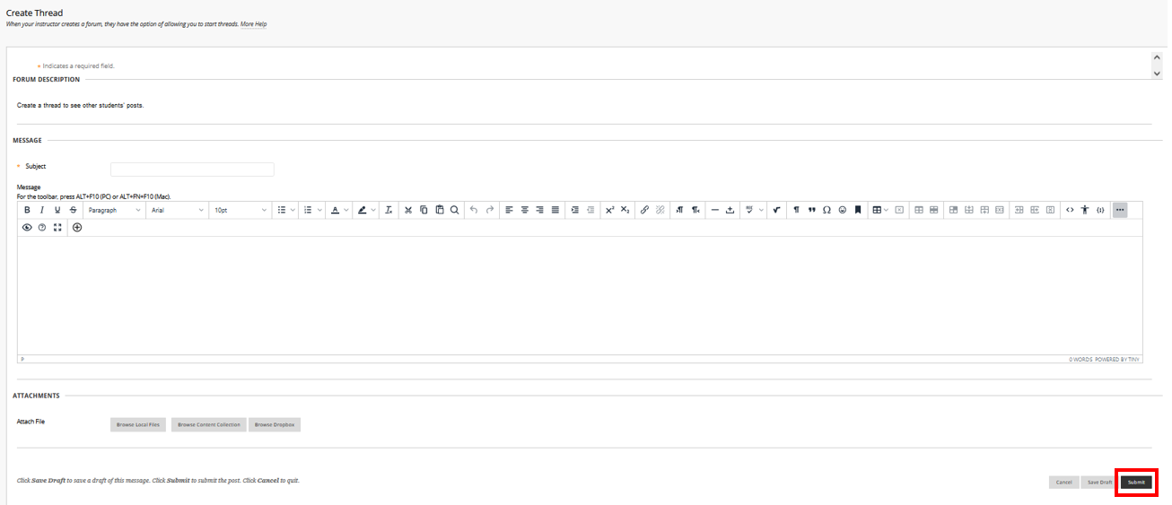

**Then, CHECK to make sure that your Discussion Board post appears on the correct Discussion Board.**

## How To Make a Reply to a Discussion Board Post

Once you have created a thread, you should be able to see other students’ threads (as long as other students have already created threads). The window should look like this, just with more rows (1 row per student):

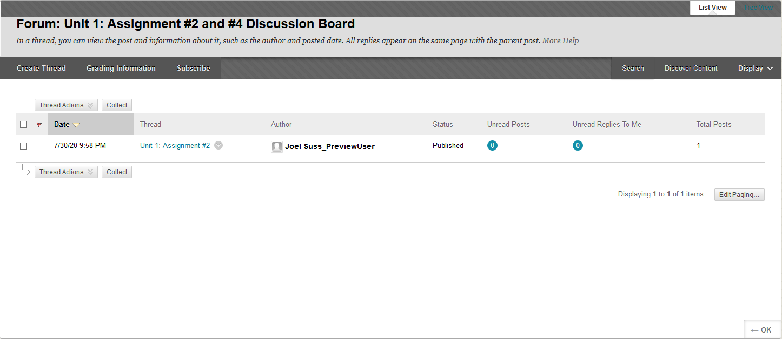

To make a reply to a Discussion Board post, you must first find the student’s thread to which you want to reply and click on it. At the end of the thread to which you want to reply, you’ll see the word “Reply.” Click on that word “Reply.”

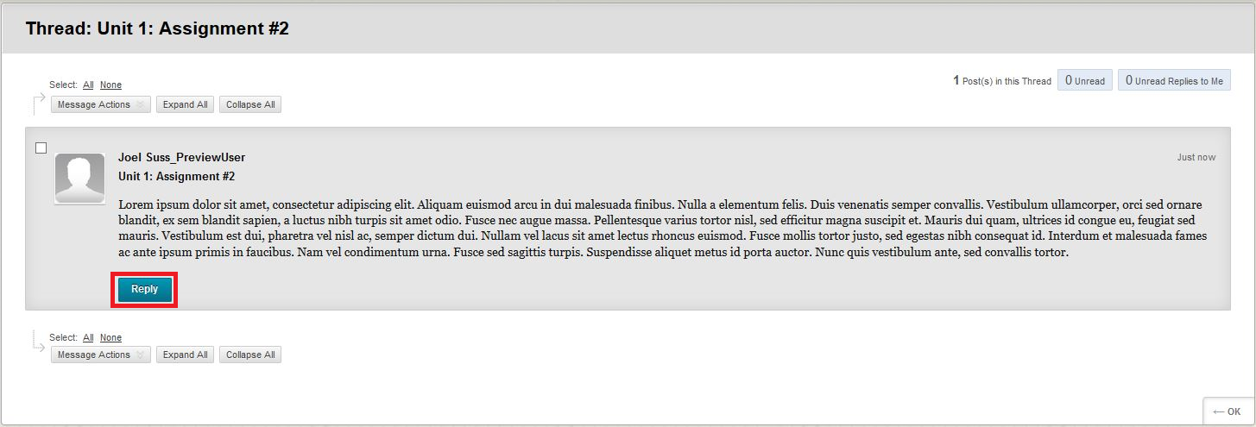

Compose your reply (either by typing into the text box or by copying/pasting what you’ve typed elsewhere, being sure to use paragraph breaks but remove extra blank lines). Then click “Submit.”

By clicking on the “Reply” that is at the end of the post to which you want to reply, you will be replying to that specific post.

## How do I Respond to Other Students’ Discussion Posts?

Each response you write to another student MUST be at least 200 words long and must include AT LEAST TWO of the following four types of response:

* A COMPLIMENT:
  + I like how ...
  + I like that ...
* A COMMENT:
  + I agree that ... because ...
  + I disagree that ... because ...
* A CONNECTION:
  + I have also read that ...
  + I have also seen that ...
  + I have also heard that ...
  + I have also thought that ...
* A QUESTION:
  + I wonder why ...
  + I wonder how ...
  + I wonder who ...
  + I wonder what ...
  + I wonder when ...
  + I wonder where ...

## How To Edit a Discussion Board Post

In this course, you **cannot** directly edit or delete a previous Discussion Board post. **Therefore, BEFORE you post any assignment, you must check and double-check it against the requirements**.

Make sure your assignment is complete and **all parts have been submitted together**. If you submit only part of an assignment, that part will be considered your initially submitted assignment, even if you submitted it before the due date or you submitted another part before your assignment was graded.

Similarly, if you re-post an assignment or add an additional part of an assignment (by making a repeated, corrected post for any assignment), your re-posted self-corrected post will be considered a correction (eligible to earn 2 points, but not eligible to earn 3 points) even if your initial assignment had not yet been graded when you re-posted your assignment or you self-corrected your assignment before the due date.



Always make sure your post actually appears **on the correct Discussion Board**.

If you don’t see your post on the correct Discussion Board after you’ve clicked “Submit,” then your post wasn’t successful. You’ll need to try again.

**It is YOUR responsibility to ensure that ALL your posts appear on the correct Discussion Board.**

## How To Embed a YouTube Video or Vimeo Video into a Discussion Board Post

In addition to typing text into a Discussion Board post, you can also embed several things—images, videos, URLs—into your Discussion Board posts. In our course, you might want to share various YouTube videos with other students. Moreover, learning how to correctly embed a variety of media into your Discussion Board posts will carry over to your knowing how to embed media into other Internet-based platforms (such as blogs, websites, and the like).

The right way to embed a YouTube video into a Discussion Board post is NOT to simply copy and paste the YouTube video’s URL into a Discussion Board post. On most platforms, if you simply copy and paste in the URL of a YouTube video, then everyone who wants to watch that video has to click on that URL, open a new browser window, and watch the video in a different browser window. That’s a pain.

Instead, you want other members of the class to be able to watch your YouTube videos you post, right there, in your Discussion Board post. So, you will make it easy for everyone to watch the YouTube videos (and Vimeo videos, for that matter) you post by embedding them the following way.

At the place in your post where you want to insert a YouTube video, click the icon (or for Vimeo, click the “+” icon.

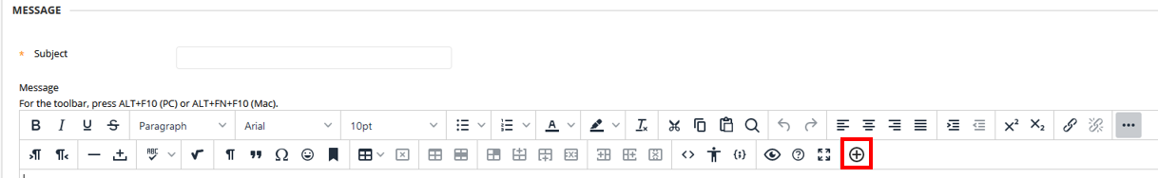

A window will pop up. **Paste the URL of the video directly into the “Search” box.** Then click the “Go” button.Then “Select” the correctvideo.

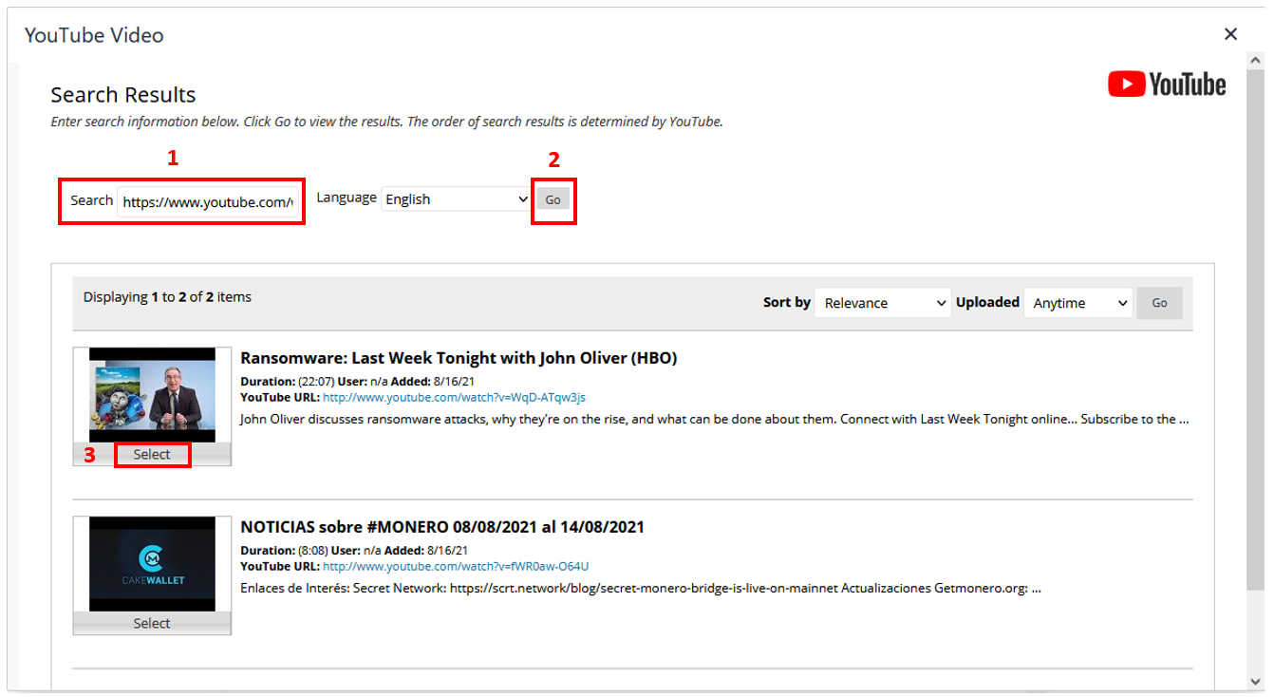

In the new window that pops up, leave all the Mashup Options at the default setting and then click “Submit.”

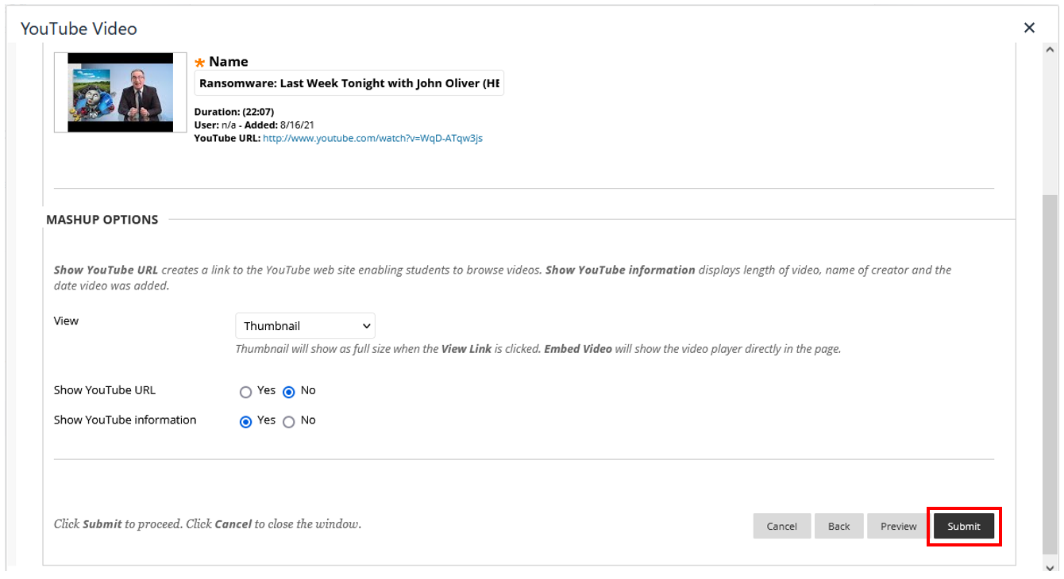

## How To Embed a URL into a Discussion Board Post

During the course, you will be required to embed links (URLs) to articles or other pieces of information on the Internet. Just as it’s lazy to link to a YouTube video by simply copying and pasting the YouTube video’s URL into your post (rather than going through the steps that will embed the YouTube video into your post), it’s also lazy to link to a URL by simply copying and pasting the URL into a Discussion Board post (rather than going through the steps that will allow the URL to be embedded into your post).

Take a look at your favorite websites or blogs, and you’ll see they embed their URLs. Embedded URLs look like this; they don’t look like https://en.wikipedia.org/wiki/Uniform_Resource_Locator, or like Link. In this course, we will be embedding URLs.

To embed a URL into a Discussion Board Post, first, type the text in your Discussion Board post that you want to be linked. For example, if you want to share the website, Wikipedia, type the word, Wikipedia.

Second, highlight with your cursor, the word or phrase that you want to be linked (e.g., Wikipedia). It’s a good idea to have at least one character to the right of the text that will not be part of the link, and therefore there will be at least one character to the right of the text that you will not highlight. A period at the end of a sentence can serve this purpose, or you can type your entire sentence (or your entire Discussion Board post) and then come back to highlight the text that you want to link.

Third, while the text that you want to link is still highlighted, click on the Link icon, which is the second icon on the second row of Discussion Board tools. The Link icon looks like two links of a chain.

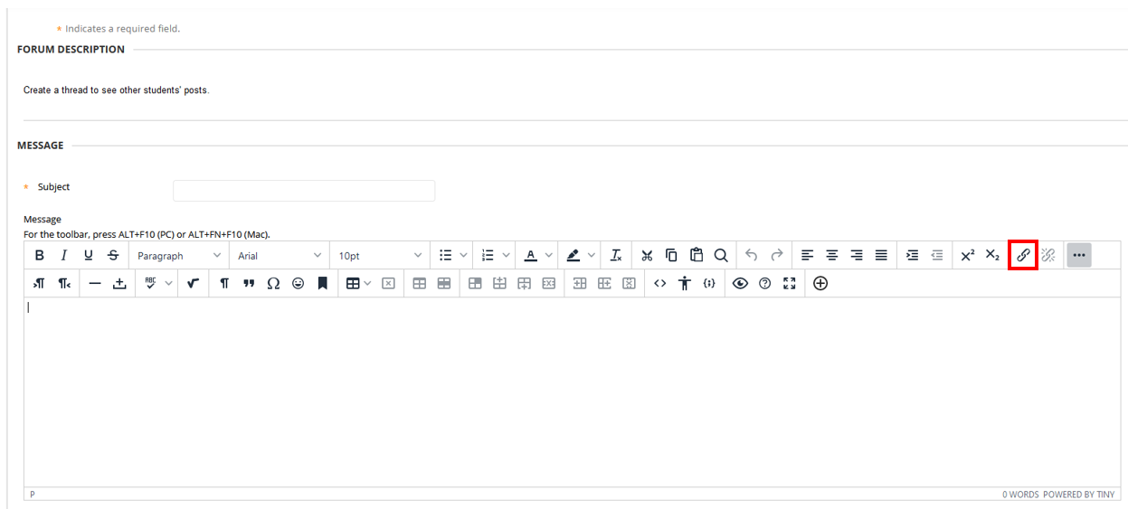

After you click on the Link icon, a pop-up window will appear, asking you to paste or type a URL into the box. Paste the link into the “Url” box (1). In the “Text to display” box (2), you can type in text that will be displayed in your post instead of the URL. Note how I typed “Wikipedia. This way, the link will appear like this “[Wikipedia](https://en.wikipedia.org/wiki/Main_Page)” rather than like this “<https://en.wikipedia.org/wiki/Main_Page>”. Then make sure that you set the “Open link in…” box to be “New Window” (3). If you don’t do this, when others click the link it will open up in the same window, replacing the Discussion Board (what a pain!). Finally, click “Save” (4).

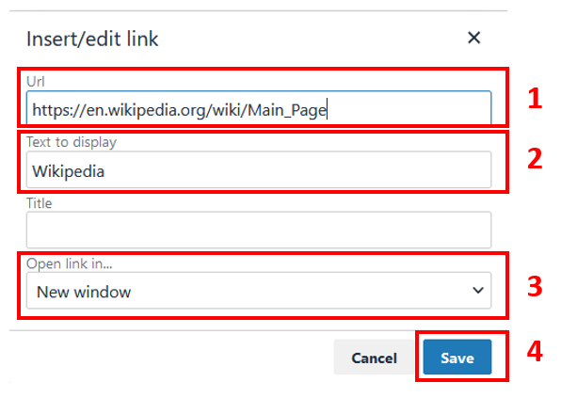

You’ll be taken back to the Discussion Board. You’ll see that the text that you previously highlighted is now blue and underlined, because it is now a clickable link.

If instead of following all these steps for Embedding a URL, you simply copy/paste a URL into the Discussion Board, it will look like plain text (https://www.wikipedia.org/); it will not be a clickable link. That’s **not** what you want. You want your embedded URLs to look like this: One of my favorite websites is [Wikipedia](https://www.wikipedia.org/).

## How To Embed an Image into a Discussion Board Post

Find an image you want to embed (e.g., on the Internet) and then save the image to your computer as an image file (e.g., .jpg, .png, .tif).

The first thing you need to do is size the image. We don’t want huge images taking up space on our Discussion Board, and we can’t see tiny images. **You need to size every image you embed into a Discussion Board post** so that each is no taller than 500 pixels high and no wider than 500 pixels wide. To do this, you can use a program such as [Microsoft Paint](https://www.uwrf.edu/CMSTraining/Documentation/ResizeImageInPaint.cfm), or you can use an online service such as [this](https://www.iloveimg.com/resize-image). Whichever option you choose, you should set the smallest dimension (i.e., height or width) to be equal to 500 pixels. Make sure you save the resized image to your computer.

Then, place your cursor in the spot in your Discussion Board post where you want the image to appear. Then, click on the “+” icon.



A new window will pop up. Click on “Insert Local Files” and then locate the image you wish to upload. Once you have located it, the “Image” box should contain a link to the image.

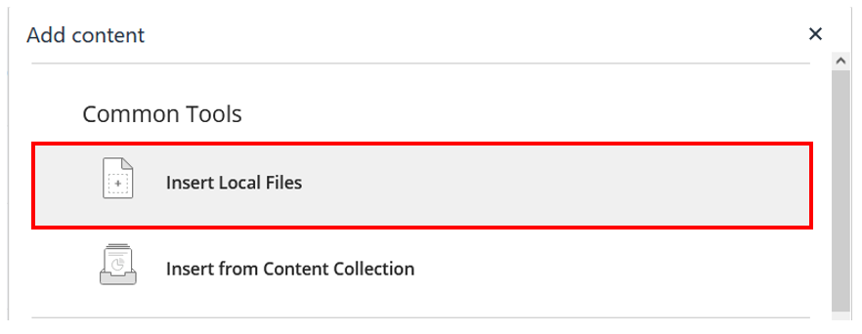

Navigate/browse to your resized image and select it. It should automatically be inserted into your post.

## How to Attach a PDF to a Discussion Board Post

To attach a PDF to a Discussion Board post:

Then, place your cursor in the spot in your Discussion Board post where you want the PDF to appear (as a hyperlink). Then, click on the “+” icon.



A new window will pop up. Click on “Insert Local Files” and then locate the image you wish to upload. Once you have located it, the “Image” box should contain a link to the image.



Navigate/browse to your PDF file and select it. It should automatically be inserted into your post as a hyperlink.

# My Grades

## How To Check the Points You’ve Earned in this Course

Get in the habit of frequently checking the points you earn. All opportunities to earn points occur during the course (rather than after the course is over, e.g., there’s no bumping or extra credit, although there are easy-to-earn points during the last unit). To check your points, go to the Blackboard Course Website. In the left-hand set of menu tabs, click on the tab labeled **My Grades**.

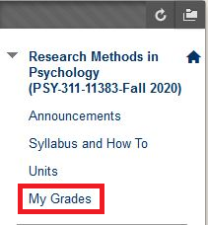

In **My Grades**, if there’s a number in the Grade column, that means that assignment has been scored, and the number represents the points you’ve earned. *Remember you can earn a total of 252 points in this course.*

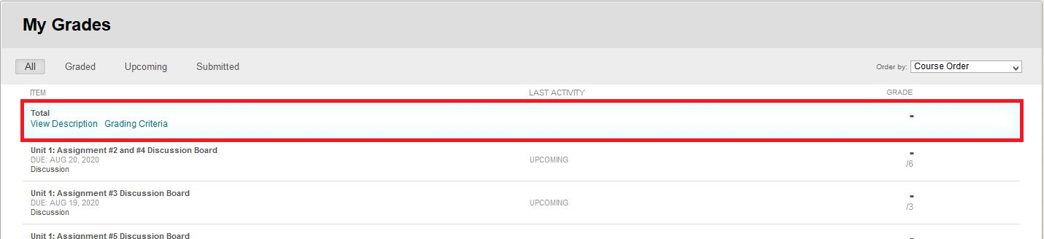

In **My Grades,** all of your assignments should be listed. In the “GRADE” column:

* A score means your submission has been graded.
* A dashed line means you have not submitted an assignment.
* A dashed line and an exclamation point means your submission has not been graded yet.
* A comment bubble means your instructor has left you feedback.
* A clock-like icon means your work is in progress, but you have not submitted the assignment.

Rubrics will be used to grade your assignments. For each assignment, the rubric will be available as a link found under the assignment's title. Click on the link to view the instructor’s/teach assistant’s comments.

Clicking the title of an assignment will allow you to review your submission, grade, and comments.

*It is in your best interest to ALWAYS read these My Grade comments, even if you have earned full credit on your assignments.*

## How To Correct an Assignment and Notify the Instructor to Re-Score It

If you complete an assignment before its due date, but your initial assignment didn’t fulfill all the requirements, you can correct your assignment. But you must correct your assignment before one week after the assignment’s due date AND you must notify the instructor.

**To correct your assignment**: For Discussion Board assignments, simply return to your post on the Discussion Board. Then, make a reply post to your original Discussion Board post (see above instructions for how to make a reply post). For “Assignment” type assignments, simply click “Re-Submit Assignment” button. For all assignments, **post your ENTIRE corrected assignment—**not just the content you’ve changed, but **everything required in the assignment** including any attachments.

**To notify the instructor that you’ve corrected your assignment**: After you’ve posted your corrected assignment, compose an email to Joel. The subject should be “PSY 311: Assignment Correction”. In your email, specify the Unit/Assignment and **describe in detail the changes you’ve made.** Be sure to explain precisely what you corrected. But if you don’t write an email telling your Instructor that you’ve corrected your assignment, it won’t be re-scored.

Lastly, **it’s your job to pinpoint how your initial assignment didn’t fulfill all the assignment’s requirements**. The best way to do that is to re-read the assignment and then look to see which aspects were not included in your initial assignment or which aspects were included but incorrectly.

# Chats

## How to Find Out Which Chat Group You Are In

Your chat group assignment for Units 3–8 is listed on Blackboard under Groups:

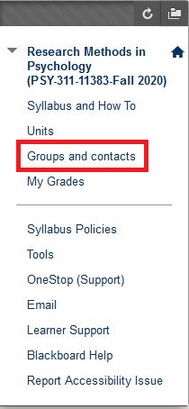

## How to Contact Other Members of Your Chat Group

On Blackboard, under “Groups and contacts,” there will be a document that lists the members of all groups. In that documents, there is also a list of each student’s WSUID and their email address.

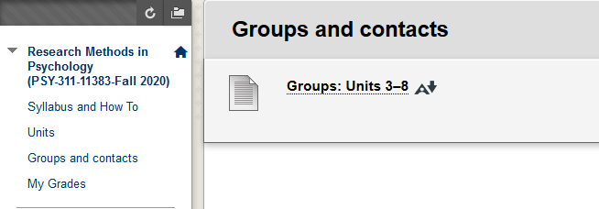

## How to Set Up a Group Text Chat using Chatzy.com

Setting up a Group Text Chat Room is the responsibility of the group’s chat leader. Here is how to do it.

Just before it’s time for your group chat, go to [Chatzy.com](http://www.chatzy.com/). Click on .

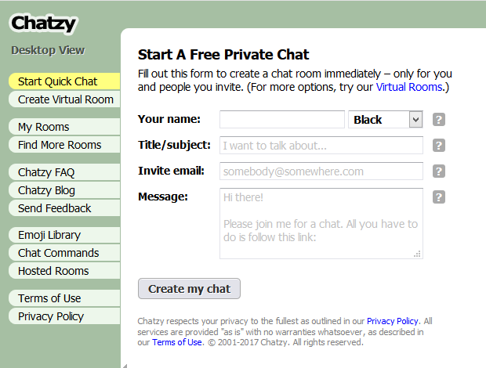

Enter the following:

* Your name: Enter your first name (i.e., the first name of the group’s chat leader).
  + Leave the color as “Black”.
* Title/Subject: Unit number, assignment number AND your Chat Group’s name.
  + For example: Unit 3: Assignment #6: The Data Sharers
* Invite email: Insert the WSU email addresses of all Chat Group members, separated by a comma.
  + Make sure to include your own email address (just as backup).
* Message: Use the default message or create your own.

Then click on 

## How to Participate in a Group Text Chat

Just before your group’s selected chat time, check your WSU email for an email from [user@chatzy.com](mailto:user@chatzy.com). That email should contain a link to the Chatzy.com chat room (that was sent to you by your group’s chat leader). When you click on the link, you should see something like this:

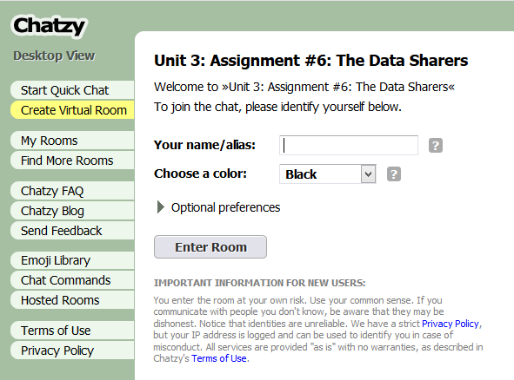

Do the following:

* Your name/alias: Enter your first name.
* Choose a color: Select a color other than “Black.”
  + This will help to distinguish between cat group members.
* Click on .

Once you have entered the chat room, everyone in the chat group can start chatting by typing in the box at the bottom of the screen! Here is a [quick video](https://www.youtube.com/watch?v=P13B-xptEtQ) overview.

## What to do if…

|  |
| --- |
| **IMPORTANT:**  **If your Chat Group agrees on a date and time for your Chat, and a Chat Group member wants to reschedule, you are NOT obligated to reschedule.**  **Also, if one member of the Chat Group hasn’t joined the Chat by 15 minutes after the time the Chat Group all agreed to meet, the other members of the Chat Group can and should PROCEED WITHOUT the missing member.**  **All Group Chats are required to last ONE FULL HOUR. During that entire hour, the Group Chat should be the ONE and ONLY thing you’re doing. If you finish early, then practice the assignment more or discuss further implications.**  **All Chat Group work MUST be done within the Group Chat room, NOT elsewhere.** |

## How to Save and Attach a Group Text Chat Transcript

When you’re finished text chatting with your Group (and you’ve chatted for a full hour), one member of your Chat Group will need to save and attach (to the Discussion Board) your Chat Group’s Text Transcript.

Chatzy.com has a built-in way to produce a chat transcript:

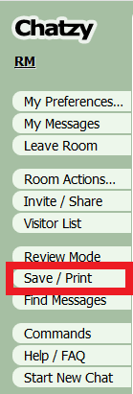

When you click on “Save/Print,” Chatzy.com will open up another window with the chat transcript.

You are going to use your web browser’s Print function to save the transcript as a PDF.

Here is a guide on how to do that for all popular web browsers: <https://www.digitaltrends.com/computing/how-to-save-a-webpage-as-a-pdf/>

When you save the transcript as a PDF, name your PDF the name of the Group Chat thread, which must also include the name of the Assignment number. Therefore, your file name must look something like this:

Unit 3: Assignment #6: Group X or if you want to use underscores, something like this: Unit_3_Assignment_#6_Group_X

Check your PDF to make sure it contains the complete transcript of that unit’s Chat (the entire thread). If the PDF doesn’t contain everything in the thread (i.e., that unit’s Chat), remake the PDF.

Finally, to attach (and post) the Chat Transcript PDF to the Discussion Board:

1. In Blackboard, click on the Discussion Board link in the Unit page for the assignment.
2. Look underneath the text box where you typically type (or paste into) the Discussion Board, and you will see the paperclip icon.

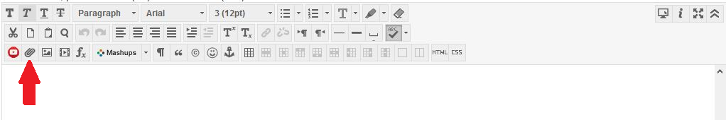

1. Click on the paperclip icon. Click on “Browse My Computer” and browse to the .pdf on your laptop/tablet and select your .pdf file.
2. Click “Submit” to upload your .pdf file.

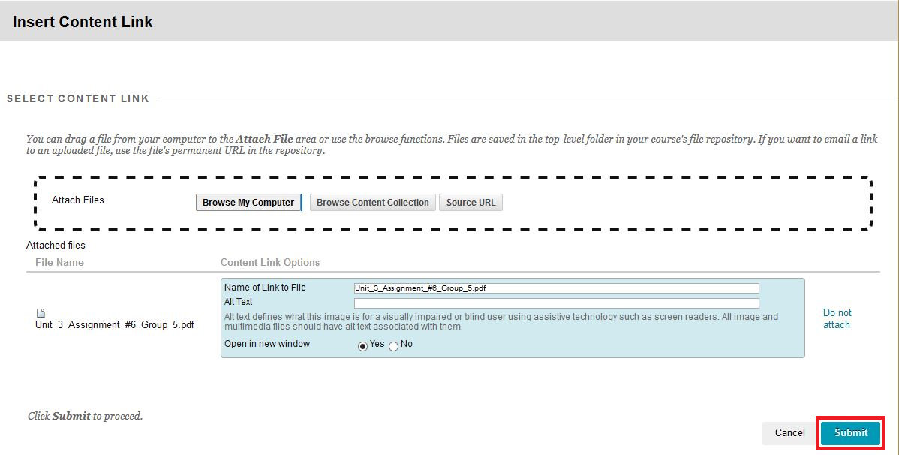

1. Then, back in the main window where you type your Discussion Board post, click “Submit” to post your chat transcript to the Discussion Board.